Using Web Bookings

Calendar Creation 1

Allocating Shifts via Web Bookings – Background Configuration 2

Changing Shift Status on the Rota and Uploading Shifts to Web Bookings 6

Staff Web Booking 8

## 

## Calendar Creation

## All allocation processes in RotaMaster start with rolling out a Shift Pattern(s) into the calendar.

Shift Patterns are configured under Rota > Shift Pattern Manager. See the RotaMaster Configuration User Guides for guidance on setting patterns with Default Staff/Rolling Rotas etc.

Shift Patterns are rolled into the calendar to create rotas using the Rota > Manage Calendar. Navigate to this screen and use the Rota Group drop down box to find the Rota Group that you wish to create a rota for, and then select the appropriate pattern in the second drop down. Then, click the Create Calendar button.

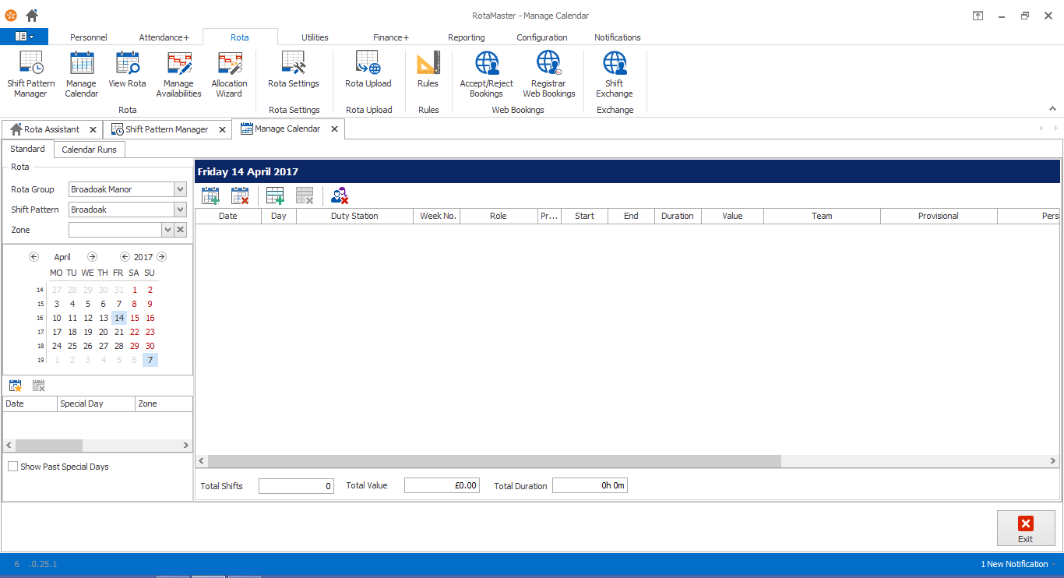

Create Calendar

This will bring up the Create Calendar screen. From here, select the Dates that you would like to create a calendar for using the two date selectors.

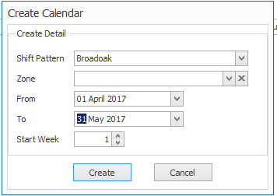

Now click **Create**. This will create a calendar using the shifts in the shift pattern selected from 01 April 2017 until 31st May 2017 in RotaMaster.

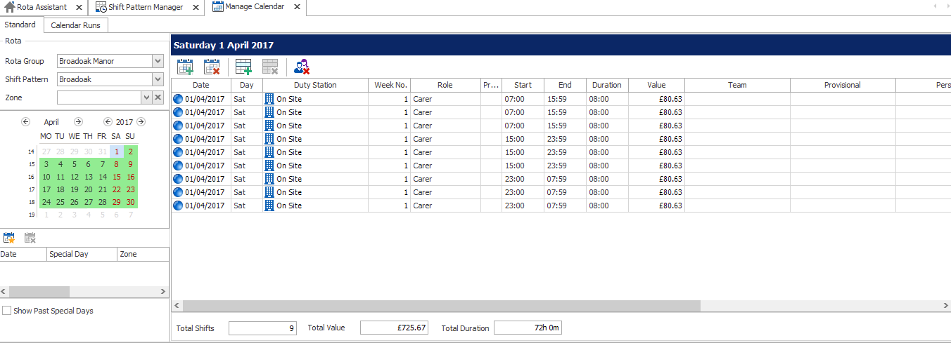

Unless there are Default People set in Shift Pattern Manager, these shifts will be empty initially and ready to be allocated. They can be filled using a variety of methods.

**Remember, these shifts will NOT be visible to staff in any area of the Web Portal until an upload is completed.**

## Allocating Shifts via Web Bookings – Background Configuration

To fill shifts via Web Bookings, you must first make sure that TWO background settings in the system are set correctly.

First, decide if each Rota Group should be using Direct or Approved Web Bookings.

* Direct Web Bookings allow staff to login to the Web Portal and book directly into shifts with no administrator intervention. The system will, however, take into account WTD, spacing rules etc.
* Approved Web Bookings allow staff to request shifts online, but RotaMaster Administrators then approve/decline the requests.

This can be set on a Rota Group basis under Rota > Rota Settings > Rota Groups.

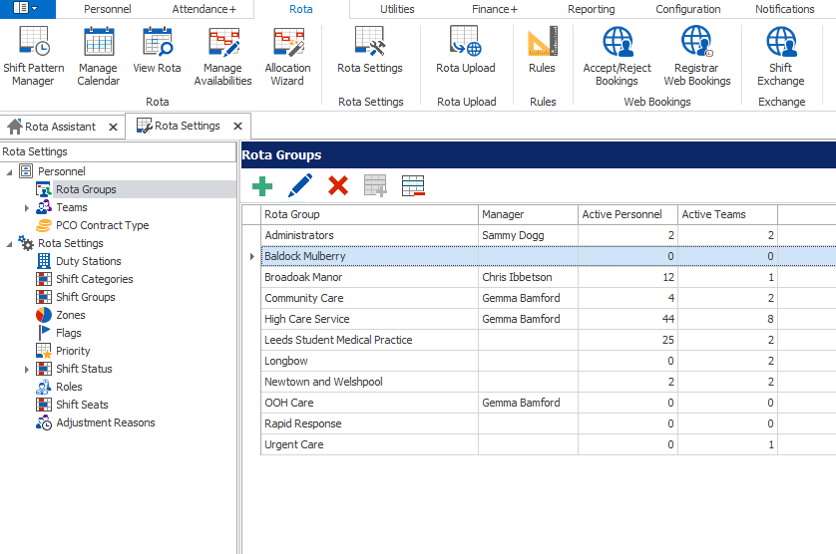

Double click on the appropriate Rota Group and navigate to Web Settings.

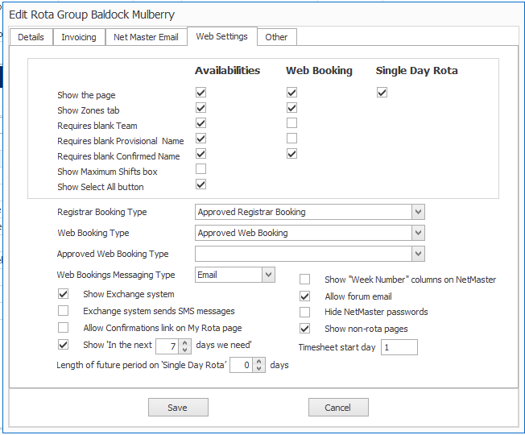

Select either Approved Web Booking or Direct Web Booking and click **Save**. This setting is ONLY for the Rota Group that you have edited.

It is then important to ensure that the Shift Status settings in RotaMaster are correct. These are configured under Rota > Rota Settings > Shift Status and can be configured differently for each Rota Group.

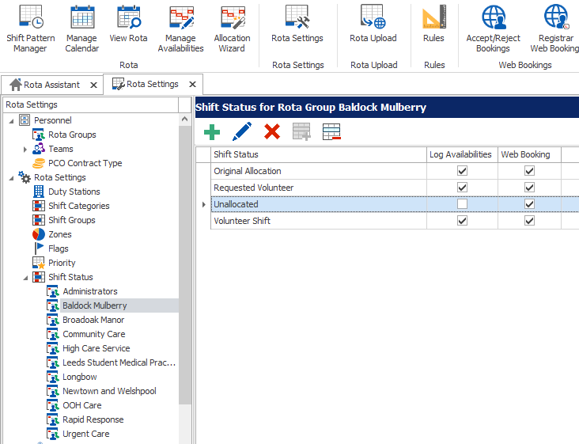

Each shift in the rota is assigned a Shift Status – which administrators can change – and it defines where on the staff Web Portal a shift is sent to when an upload is performed.

It is recommended that the ‘Unallocated’ Shift Status for each Rota Group is always set to Web Bookings. This means that when a shift in the Live Rota is set to ‘Unallocated’ it will be sent up for staff to book into on the Web Portal under Web Bookings.

To change the Shift Status settings for a Rota Group, click on the appropriate Rota Group under Shift Status on the left hand side under Shift Status, as shown above, and then double click on Unallocated.

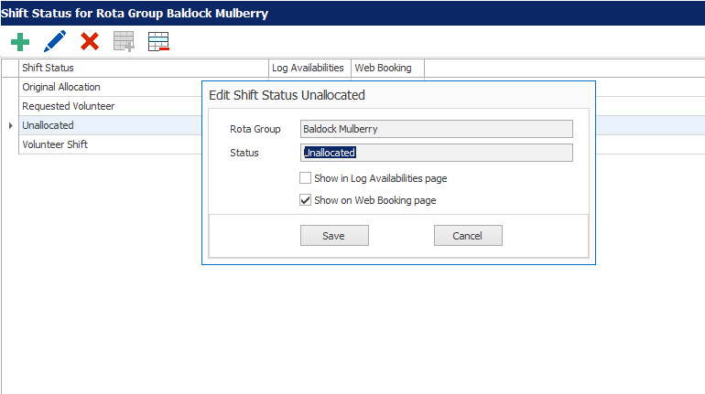

Ensure that ONLY the ‘Show on Web Bookings page’ is ticked and click Save. Repeat this step for all Rota Groups that will be using Web Bookings.

## Changing Shift Status on the Rota and Uploading Shifts to Web Bookings

Usually, once a calendar has been created, the Shift Status of all shifts will be Original Allocation by default. These shifts may already be filled by Default People from the Shift Pattern, and the Allocation Wizard may have been used to fill others. For these shifts, their status can remain as Original Allocation – meaning that when the rota is uploaded the allocated people will see their shifts in the My Rota page.

Web Bookings can be used to either fill a few available shifts, or your entire rota – depending on your preferences and allocation methods.

To send shifts up to the Web Portal for staff to book using Web Bookings, go to Rota > View Rota > Filter down to the appropriate date range.

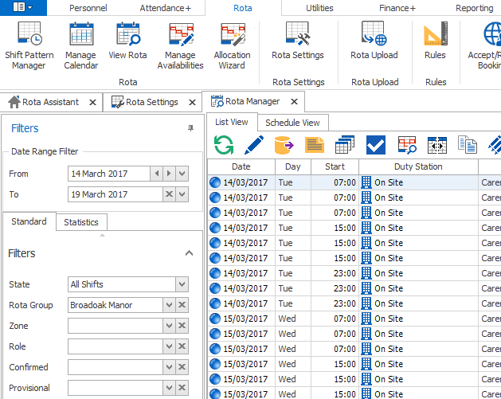

This will populate the rota screen with all shifts in that period.

Now, select each shift that should be uploaded for Web Bookings. Use either the filters on the left, or in the column headers to filter down to the appropriate shifts. For example, if you only want to see empty shifts, so that their status can be changed to Unallocated, hover over the column header on ‘Confirmed Person’;

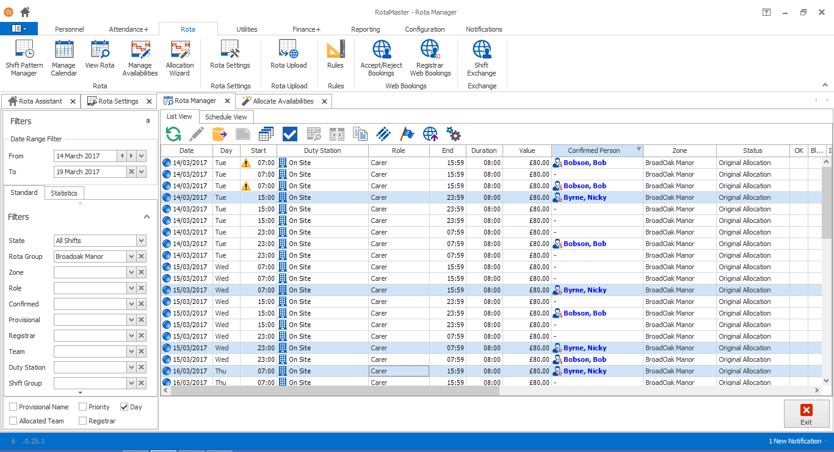

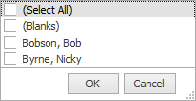Click the small sieve icon that is shown and tick the ‘Blanks’ box. The screen will now only show shifts that are blank/not filled in that time period.

Select every shift that should be uploaded for Web Bookings (either; hold Ctrl and click through the shifts, or Ctrl+A to select all the shifts in view).

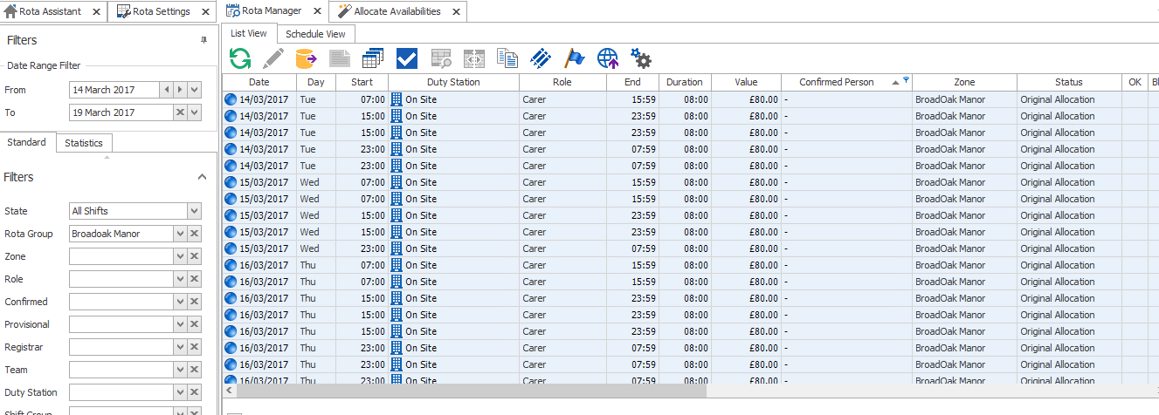

Click the Quick Edit icon and select ‘Quick Edit’

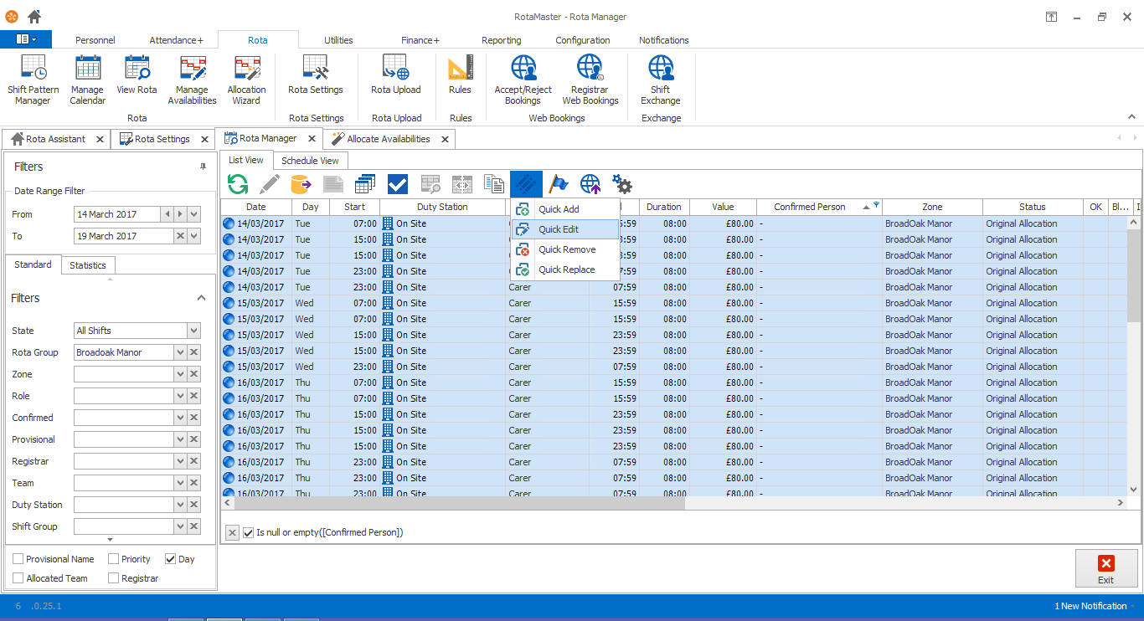

Click down the **Status** dropdown and select Unallocated, then click Confirm. This will change the Status of each shift selected to Unallocated.

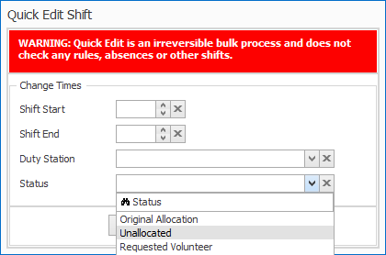

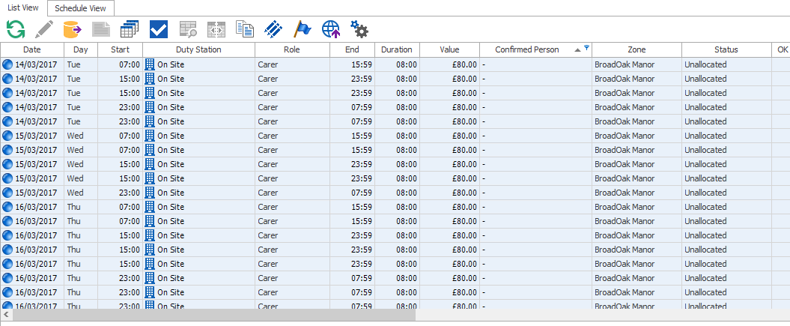

These shifts are now ready to be uploaded for Web Bookings. This can be done either as a full Rota Upload (Rota > Rota Upload), or using the Quick Upload function found on the top toolbar; .

## Staff Web Booking

Now, when staff login to the RotaMaster Web Portal, they will see a list of shifts that can be booked through Web Bookings. These will either be Direct or Approved Web Bookings, depending on the settings discussed earlier in this guide.

To see ‘Unallocated’ shifts, staff login to the Web Portal and go to **Web Bookings.**

This will open up the following screen;

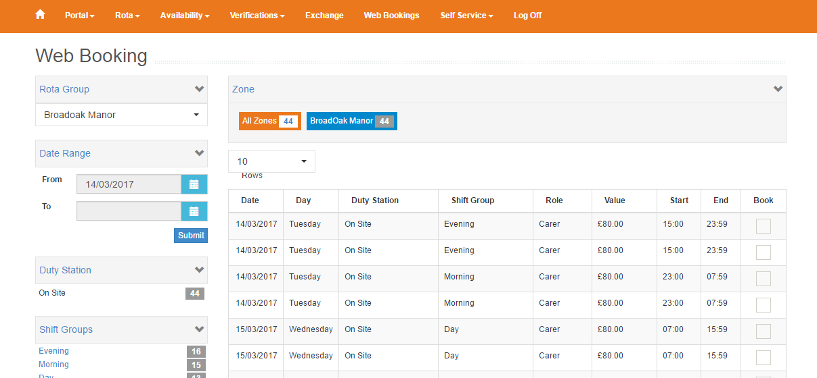

From here, staff can use the Date Range filter, Duty Station, Shift Group and Zone filters to find shifts that they want to work. The example above is **Approved Web Bookings.**

Staff members tick next to the shifts that they would like to request and click the **Request** button at the bottom of the page.

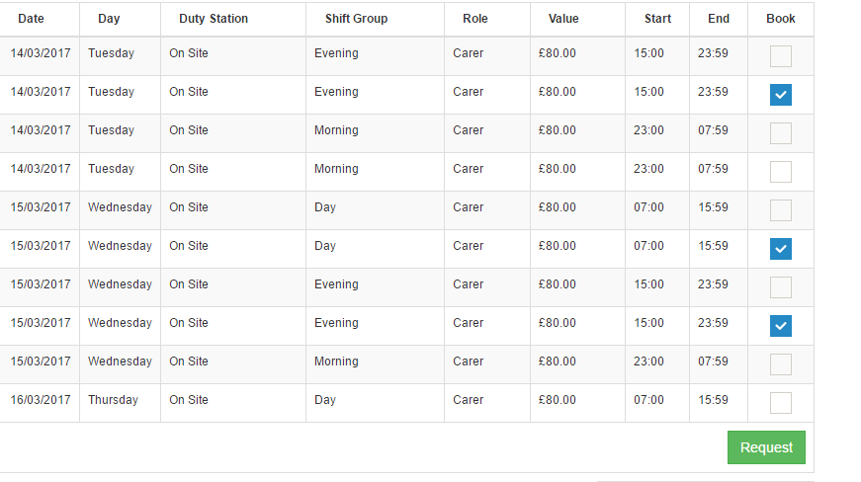

Once staff have submitted their Web Bookings on the Web Portal, they will be automatically downloaded to the **Accept/Reject Bookings** page:

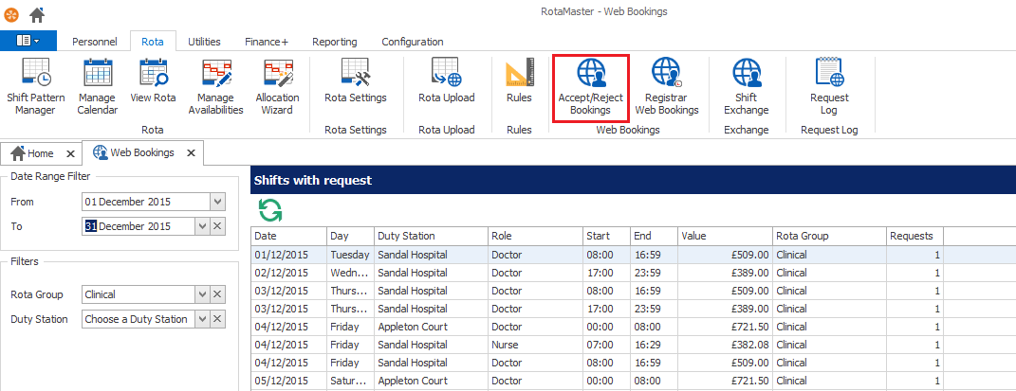

Select the appropriate date range to view Web Bookings for and, if required, the Rota Group/Duty Stations. Click the Refresh icon to ensure that changes to the filters are reflected in the main screen. The number of staff members that have requested that shift is shown in the **Requests** column.

Click a shift and this will show the details of each staff member that has requested that shift.

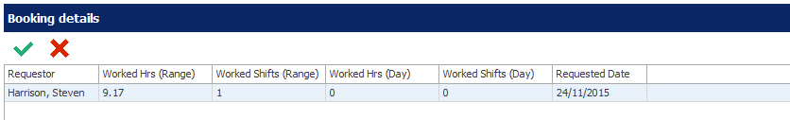

To approve a request, highlight the person that should be allocated to the shift and click on the **Approve Request** button. The following screen will be shown:

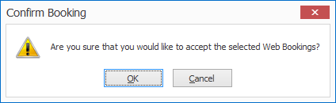

Click **OK** and the shift details will be shown;

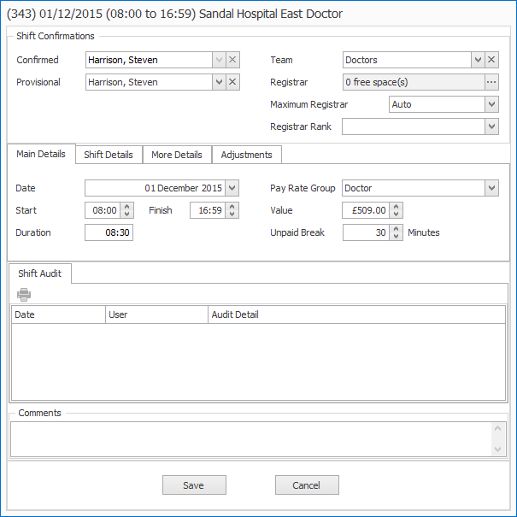

Click **Save** to continue.

The **Confirmed** person will receive either an SMS or an Email to confirm their allocation. This can be switched from Email to SMS in Rota > Rota Settings > *Rota Group Name >* Web Settings;



Every other person that requested that shift will receive a generic email advising them that the shift was not allocated to them. If administrators would prefer to send a custom message to each person advising of why they did not receive approval for the shift, they can use the Decline function described below.

To decline the request, highlight the request and click the **Decline Request** button . The following screen will be shown:

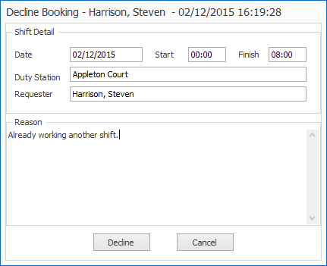

Click **Decline** and the request will be deleted and an email sent to the staff member informing them that the request has been declined.

**If using Direct Web Bookings, staff see a ‘Book’ button next to each shift in the Web Bookings screen. Once they click this – assuming no WTD, Rules or Compliance issues are found – they will be allocated the shift. Administrators will receive an email confirming the booking, but will not approve requests.**